CODE OF CONDUCT
IN CASE OF ANNOUNCEMENT OF
DANGER ALARM
IN THE DORMITORY

UwB Dormitory has fire protection systems which work automatically.
In case of detected signs of danger for residents, the fire alarm system automatically launches acoustic signals (high and loud sound). The sound alarm system launches a voice announcement (broadcast only in the Polish language), which appeals for immediately evacuation all the users of the building.
- If evacuation is necessary:
- do not waste time to save the property – your life is the most important!
- during the evacuation do not use the elevators,
- go immediately to the fire exits, follow the evacuation signs or listen to the evacuation leader’s orders,
- remember the other residents – they may need your help,
- in case of strong smoke on the escape route, move close to the ground and along the walls, not to lose orientation while evacuating,
- in case of the necessity to jump from a window at a rescue cushion, wait for fireman’s order!
- come back to the abandoned building only after evacuation leader’s permission.
- After leaving dormitory:
- inform the rescue action leader about people who are still inside the dormitory,
- if you have important helpful information, pass them to the rescuers,
- do not disturb in rescuers’ work,
- do not come back to the building without the rescuers’ permission,
- if you are hurt, inform the rescuer about this.
- If you see THE FIRE then:
- you have legal and moral duty to inform about this situation people being nearby you and the staff of the building,
- in order to inform everyone about the danger in the building, you should push the so-called button ROP (the fire-alarm box), they will hear the loud communications to evacuate from the building,
- if it is possible, use simple methods to extinguish the fire in the early stage by using an extinguisher,
- if grease is burning in the kitchen – just cover the dish by tight lid – in any case do not use the extinguisher!
- do not extinguish the electrical devices by using water – probably they are under voltage,
- do not try to extinguish the fire if you are not able to control it – lead people out of the building and take them to the safe area,
- if the fire or smell of smoke wakes you up, check if the doors are hot - if they are, don’t open them - use the other ways to leave the room (for example by the window, if it is possible) or call for help (by voice and gestures),
- if you must walk through the smoked door, then cover the mouth and nose by a thick cloth, cover yourself with something which is slow-burning and move close to the ground – smoke and heat air raise to the ceiling. Be ready, smoke irritates the eyes!
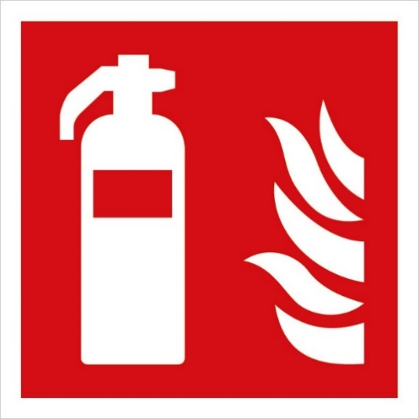
Fire extinguisher sign Fire-alarm box
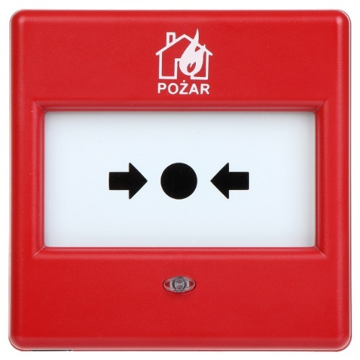
Fire-alarm box sign
