An annex to the Instruction | Evacuation safety signs
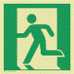 | Emergency exit (left-side)  It marks the escape route to the safe area  An additional sign with an arrow is used to give information about the  direction
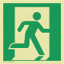 | Emergency exit (right-side)  It marks the escape route to the safe area  An additional sign with an arrow is used to give information about the  direction  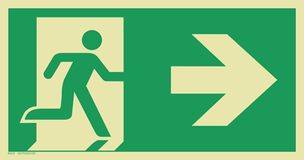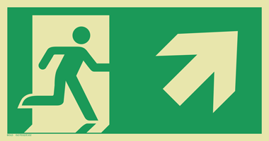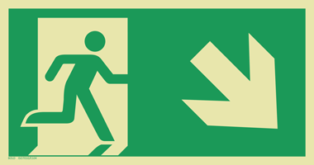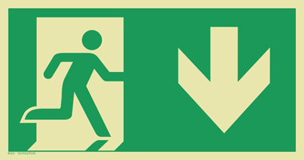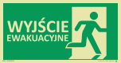
 | Emergency arrow pointing the direction of the evacuation  It is used to determine the evacuation direction (the arrow can be rotated  by a multiple of 90 angle in relation to the vertical). This mark is only used as an additional mark.  Examples of the use of the mark:
 | Arrow with 45 ° slope indicates evacuation direction  It is used to determine the evacuation direction (the arrow can be rotated  by a multiple of 90 angle in relation to the vertical). This mark is only used as an additional mark.  Examples of the use of the mark:
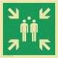 | Fire assembly point for evacuation  Marking a safe assembly point for evacuation
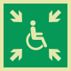 | Fire assembly point for the disabled people  It indicates a temporary safe area (hiding place) for people awaiting for help, who cannot use the stairs in case of the evacuation
 | Break to gain access  It marks the cover that needs to be broken to get access to the key, that opens the emergency exit
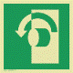 | Turn to open  It indicates that the safety door handle must be turned in a counterclockwise direction to allow the door to open
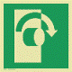 | Turn to open  It indicates that the safety door handle must be turned in a clockwise direction to allow the door to open
 | Push to open the door (left)  It indicates that after pressing the door, it opens to the left
 | Push to open the door (right)  It indicates that after pressing the door, it opens to the right
 | Escape ladder  It indicates the location of permanently secured escape ladder
 | Medical first aid  It indicates the location of the medical equipment or medical facilities
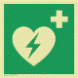 | Defibrillator (AED)  It indicates the location of the automatic external defibrillator

 | Fire safety signs
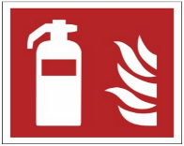 | Fire extinguisher  It indicates the location of the fire extinguisher
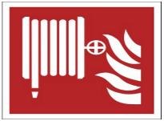 | Fire hydrant and hose  It indicates the location of the fire hydrant and hose
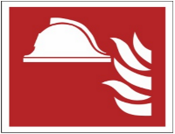 | Safety equipment set  It indicates the location of the safety equipment set
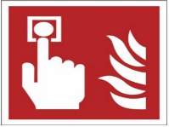 | Fire alarm  It indicates the location of the fire alarm button
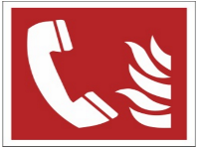 | Fire alarm phone  It indicates the location of the fire alarm phone
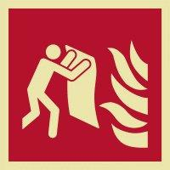 | Fire blanket  It indicates the location of the fire blanket
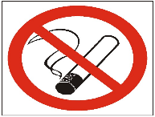 | No smoking  It informs about the smoking ban in the indicated place
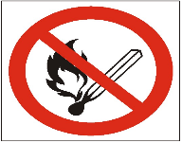 | No open fire  It informs about the ban on using open fire in the indicated place
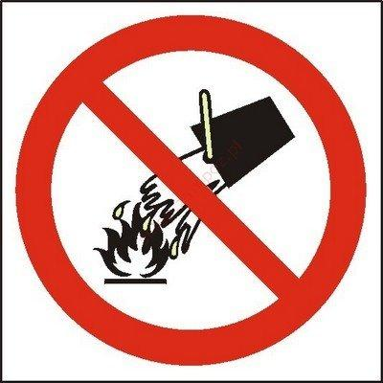 | No water to extinguish fire  It informs about the ban on extinguishing with water in the indicated place
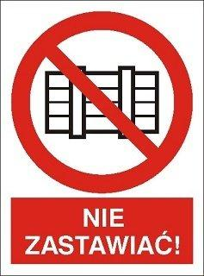 | Do not block  It informs about the ban on blocking in the indicated place
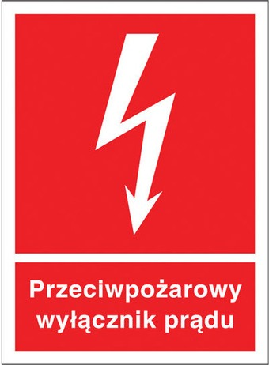 | Fire electricity switch  It indicates the location of fire electricity switch
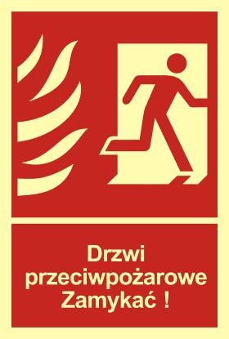 | Fire door. Close the right door  It indicates the door in walls separating from the fire
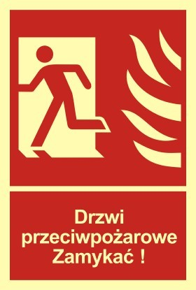 | Fire door. Close the left door  It indicates the door in walls separating from the fire
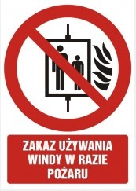 | In case of fire do not use the lift  It informs about the ban on using the lift in case of fire
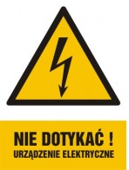 | Attention, please do not touch! Electric device.

