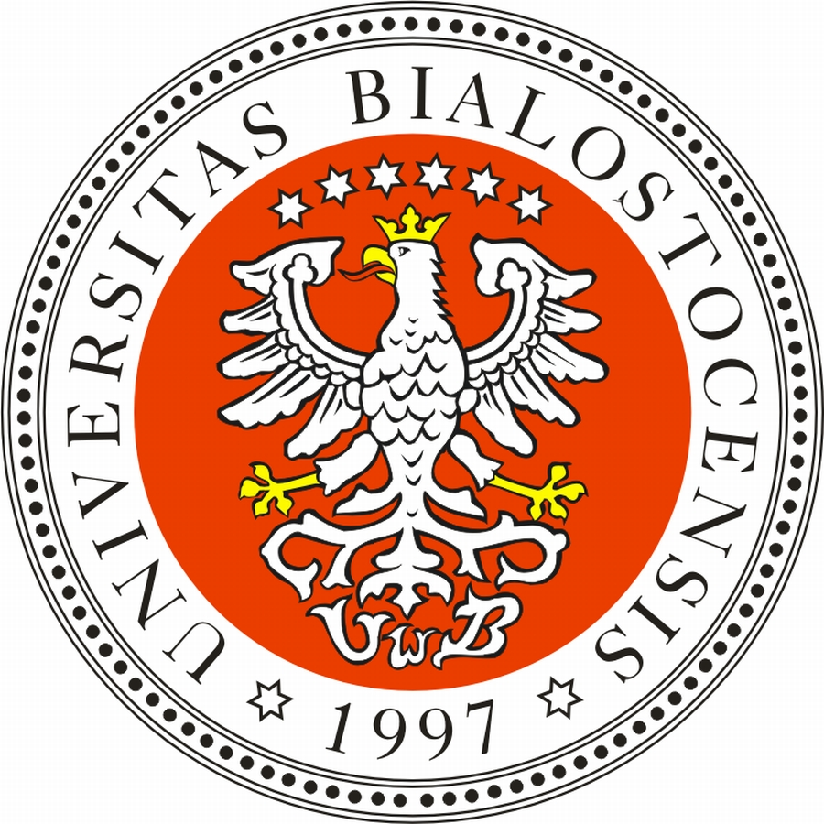 | UNIVERSITY OF BIAŁYSTOK, POLAND  2nd INTERNATIONAL STAFF WEEK  APPLICATION FORM  26th – 30th May 2025

Please fill out the Application Form and send it by e-mail to: dwmprojekty@uwb.edu.pl

PERSONAL DATA OF THE APPLICANT
Last name(s) ............................................................... First name(s) .......................................................
Place of birth .......................................................... Date of birth ………………………………………………………..
Gender: M F U Nationality .............................. Passport no. .....................................................
Current address........................................................................................................................................
Postal code ..................................... Town ..................................... Country............................................
Mobile tel. no.+............................................................... e-mail...............................................................
Native language ...............................................................

HOME UNIVERSITY: ..................................................................................................................................................................
COUNTRY AND ADDRESS: .................................................................................................................
Faculty/unit …………………………………………………………… Erasmus+ code: ………………………………………….……..
Nature of work performed*: academic staff administrative staff international relations office
Erasmus+ programme coordinator
Tutaj

CONFIRMATION FROM THE APPLICANT’S HOME UNIVERSITY
Name, position, phone, e-mail: …………………………………………………………………………………...........................
…………………………………………………………………………………………………………………………………………………………….
I hereby certify that the above-mentioned person is a staff member of our university and the information provided in this application form is correct.

Date: ...................................................... Signature: ...............................................................................

Official stamp of the Institution:

Knowledge of English language | English language proficiency level
 | B1 | B2 | C1-C2
English

Dietary requirements | none | vegetarian | vegan | no pork

Briefly state the reasons why you wish to participate at the International Staff Week,
organised by the University of Białystok. (Please, fill it out in English. Please, use another page if more space is needed.)
................................................................................................................................................................................................................................................................................................................................................................................................................................................................................................................................................................................................................................................................................................................................................................................................................................................................................................................................................................................................................................................................................................................................................................................................................................................................................................................................ Which Faculty Representative are you interested in meeting with?
................................................................................................................................................................

I hereby acknowledge that I have read and understood the information about Data Protection indicated below and I consent to the processing of my personal data by the University of Białystok for the needs as described below.

Place, date.................................................. Applicant's signature.........................................................

Information duty resulting from Art. 13 par. 1 and par. 2 of the Regulation (EU) 2016/679 of the European Parliament and of the Council of 27 April 2016 on the protection of natural persons with regard to the processing of personal data and on the free movement of such data, and repealing Directive 95/46/EC (General Data Protection Regulation):
- Data controller of candidates’ personal data is University of Białystok, Świerkowa 20B,
15-328 Białystok, Poland.
- Data controller has designated Data Protection Officer responsible for the proper processing of personal data who can be contacted via email: iod@uwb.edu.pl.
- Personal data will be processed for the purpose of International Staff Week and under other agreements concerning interinstitutional cooperation at the University of Białystok and for the purpose of contact.
- A legal basis to process candidates’ personal data is:
Art. 6 par. 1 item a of General Data Protection Regulation, i.e. – explicit, unambiguous and voluntary consent of a candidate to process his personal data for the needs of the recruitment procedure;
Art. 6 par. 1 item b of General Data Protection Regulation, i.e. - processing is necessary for the performance of a contract to which the data subject is party or in order to take steps at the request of the data subject prior to entering into a contract;
Art. 6 par. 1 item c of General Data Protection Regulation, i.e. - processing is necessary for compliance with a legal obligation to which the controller is subject;
Art. 6 par. 1 item f of General Data Protection Regulation, i.e. - processing is necessary for the purposes of the legitimate interests pursued by the controller.

- Providing personal data is voluntary but necessary to be hosted at University of Białystok.
- Data may only be disclosed to your home institution or other external entities in cases envisaged by the provisions of law.
- Data will be stored for the period necessary for the purposes of processing, and for the period required by the International Staff Week regulations or by other agreements concerning interinstitutional cooperation regulations.
- You have the right of access to and rectification or erasure of your personal data as well as restriction of data processing and portability and objection to data processing and revoke your consent.
- Whenever data processing infringes the provisions of the law in force, you have the right to lodge
a complaint with supervisory authority.
- Personal data submitted will neither be processed automatically nor profiled in any way.

